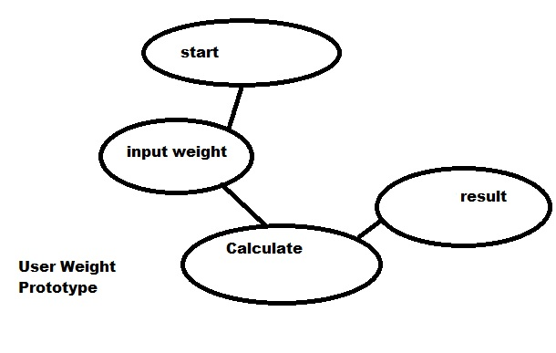
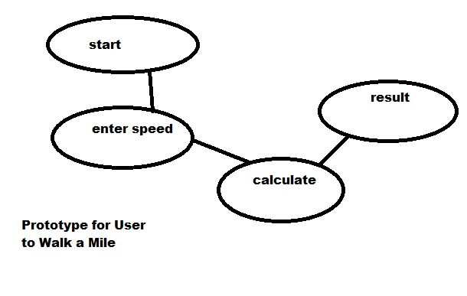
Andrew Dykman – Software Development Lifecycles – Lab 3

Task 1.)
Question A.) Seperate Reports
Question B.)

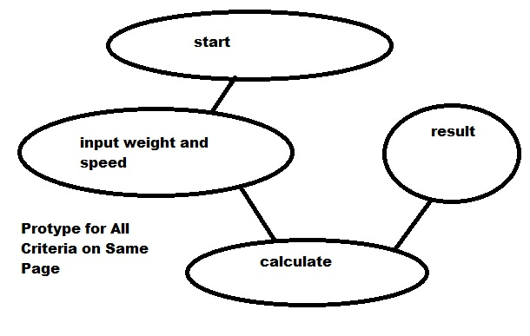
Question C.) These prototypes will help me refine my requirements by giving me a visual depiction of the logical flow of the program in order to help me establish what the program needs to do, what data it needs, and what calculations need to be performed and the order they need to be done in as well as giving me an overall idea how the program should function.

Task 2.)

Task 1.) Create a word document (using this one to keep lab more organized.)
Task 2.) List the nouns in the system: Weight, Speed, Calculate, Result
Task 3.) Determine which classes are primary: Calculate, Result
Task 4, 5.)
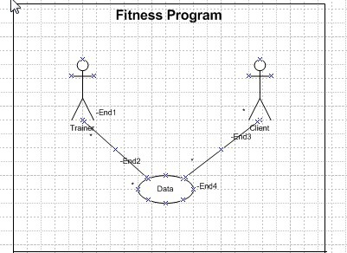
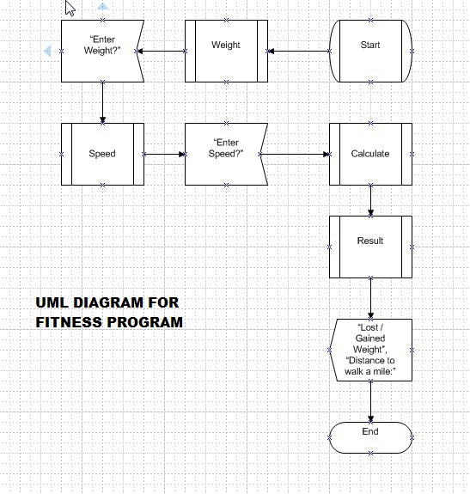

Task 6.)

